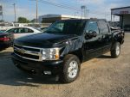
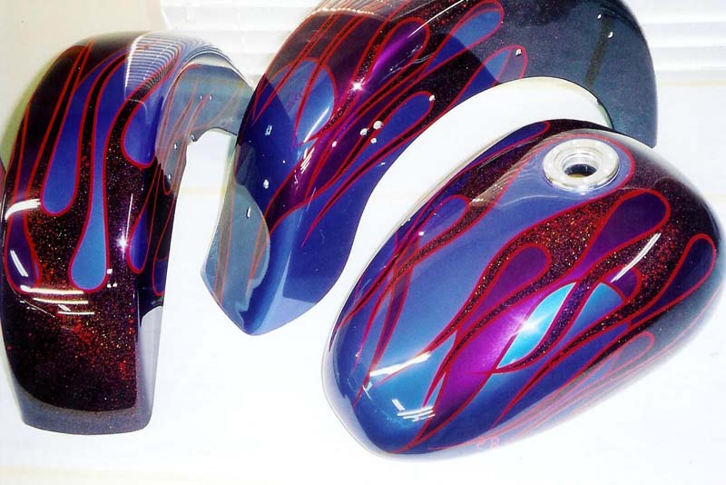
Lake Career & Technical Center
PO Box 1409
Camdenton MO
65020
Phone 573-346-9260 ext. 365
Fax 573-346-9284
Email gbrisoe@camdentonschools.org

Collision Repair Technology
Collision Repair & Custom Painting Basics
Student Handbook
Instructor: Garry Briscoe
Course Description:
Collision Repair & Custom Painting Basics
This course will give students an opportunity to learn the skills, as well as explore the many career opportunities available in the Collision Repair and Automotive Customizing industry. Our primary source of instruction is ICAR Curriculum which our industry’s most recognized and leading supplier of certification and training. Math embedded credit is offered to enhance the academic skills needed to be a professional in our field of study. Students will leave the class with knowledge of the industry, a general overview of transportation in general, and a heightened understanding of the work ethics needed to be successful in the world of work.
Collision Repair Technology
This program meets industry standards with regard to refinishing, structural, and cosmetic damage repairs. The program aggressively seeks to produce students that will succeed in the automotive industry. This program will also strive to inspire students to pursue a higher education along with other options that may improve their opportunities for success.
Collision Repair Technology is an advanced program for students wanting to enter the collision repair field. This class will teach the fundamentals of cosmetic auto body repair, unibody, and full frame repair. Students will learn advanced welding skills, including MIG, TIG, as well as Plasma Arc cutting. Refinishing techniques for panel repairs, overall refinishing, and custom painting will be extensively covered. Cosmetic marine fiberglass repairs will be taught, along with gel-coat repair procedures. The latest technology in measurement, estimating, vehicle construction, and repair process will be covered. Communication skills and math are taught throughout the program. This class also includes the opportunity to pursue embedded math credit.

In addition:
The Collision Repair Technology program will cover the basics of collision repair and refinishing. We have a very “up to date” lab and classroom area that provides students with the latest technology for the repair of motor vehicles.

The Collision Repair Instructor (Garry Briscoe) is a graduate of the program and has worked in the Collision Repair Industry for 30 years as a Paint Technician, Estimator, Insurance Adjuster, Collision Shop Manager, and Marine Repair Shop Owner/Operator. He is also a current officer and founding member of the Missouri Collision Repair Instructors Association (MCRIA), a non for profit corporation that has the goal of unifying the type of curriculum taught across the state and enhancing all aspects of your Collision Repair learning experience.

We are proud to have adopted I-CAR curriculum as the main source of instructional materials for our program. I-CAR is an industry based, non for profit training program, which allows technicians to acquire the latest training available for a quickly changing Collision Repair Industry. Students who have completed each I-CAR training module with a passing grade will be eligible to purchase I-CAR Points directly from I-CAR at a significant discount over a typical industry technician.

Our Collision Repair program is offering a Technical Math embedded credit to eligible students. All students will participate in the math portion of our program as it is a required skill of great importance to be successful in today’s workforce.

Our Collision Repair program students will have an opportunity to learn many of the skills needed to be successful in the Collision Repair industry. We will work in the classroom as well as displaying our skills on live projects. Students who complete the classroom and lab activities with accuracy and enthusiasm will be allowed to work on their own projects at the instructor’s discretion.

What does a collision repair technician do?

Thousands of motor vehicles are damaged in traffic accidents every day. Although some are sold for salvage or scrapped, most can be repaired to look and drive like new. However, it can be challenging because each damaged vehicle presents a different problem. Collision repair technicians must develop appropriate methods for each job, using their broad knowledge of automotive construction and repair techniques.
General tasks of a collision repair technician include: estimating damage, straightening bent bodies, removing dents, replacing crumpled parts that are beyond repair, mixing and matching paint colors, spraying paint and refinishing them to a lustrous shine. Usually, they can repair all types of vehicles, but most collision repair technicians work on cars and small trucks.

Training for a Career in Collision Repair

Today's vehicles are made of more than just ordinary steel. Many auto manufacturers now use high-strength steel, aluminum and plastic, which present special challenges for the repairer. Few people realize that collision repair technicians work with computers and high-tech equipment. Additionally, vehicles must be repaired according to factory specifications. With all the advances in technology and repair standards today, a collision repair professional must be highly skilled and appropriately trained.

Interested students should have good reading and basic mathematical skills as technicians are required to make very precise measurements, and often refer to technical manuals. Additionally, advances in technology in recent years have greatly changed the structure, components and materials used in automobiles. As a result, students must have good problem solving skills.

Some students enter the collision repair profession right out of high school while others pursue additional training from a post-secondary institution before starting their careers. In either circumstance, they are usually hired as entry-level technicians, performing basic repairs or detail work.

Generally, it takes about 2 to 3 years of on-the-job training to be considered a "productive" technician. This is when the technician is experienced enough to handle the most complex repairs with little or no supervision. Though, formal training can significantly increase ones chances for advancement and higher wages.

For the 2013-14 School years you will be utilizing the most recognized instructional materials available to the collision repair industry.

Non Structural Collision Repair Courses:
Hazardous Materials, Personal Safety, and Refinish Safety (WKR01)
Trim and Hardware (TRM01)
Advanced High-Strength Steel Overview (AHS01)*
Automotive Foams (FOM01)
Steel Unitized Structures Technologies and Repair (SPS07)
Bolted-On Part Replacement (EXT01)
Movable Glass (GLA01)
Cosmetic Straightening Steel (STS01)
Plastic and Composite Repair (PLA03)
Lighting, Starting, and Charging Systems (LSC01)

Refinishing Technology Courses:
Hazardous Materials, Personal Safety, and Refinish Safety (WKR01)
Trim and Hardware (TRM01)
Surface Preparation and Masking (REF02)
Surface Preparation and Masking (REF02e)*
Refinishing Equipment (REF01e)*
Refinishing Equipment and VOC Regulations (REF01)
Hazardous Airborne Pollutant Reduction (HAP01)*
Liquid and Solid Hazardous Waste Storage and Disposal Overview (HWD01)*
Corrosion Protection (CPS01)
Detailing (REF04)

Additional instruction will include fiberglass repair & customer service.

Link to CRT Power Standards: http://camdentonschools.schoolwires.net/cms/lib01/MO01001301/Centricity/Domain/789/Collision%20Repair%20Tech%20power%20standards%20crt.pdf

Collision Repair Technology Code of Conduct
- I will conduct myself as a professional when participating in lab activities
- I will wear safety glasses at all times in the lab area
- I will be responsible for the proper use of our tools and replace them in there designated areas after use
- I will maintain our tools and equipment as necessary to keep them in good working order
- I will keep our lab and classroom area clean
- I will abide by all safety rules set forth by the instructor and practice good use of common sense in regards to safely working in the lab area
- I will treat all projects with respect and only have contact with vehicles that I have been assigned to work on

I understand and agree to conduct myself as outlined above: signed____________________ date: ________

Please understand that any student who creates a hazardous working atmosphere for themselves or other students will not be allowed to participate in lab activities

